UNIVERSITY OF BEDFORDSHIRE
EZHILARASI SUBRAMANI
1955189

A Study Evaluating the Role of Big Data Analytics in the Healthcare Sector of the UK

Table of Contents
1. Description of Topic and Research Area 4
1.1 Research Background 4
1.2 Research Rationale 4
1.3 Research problem 4
1.4 Research Aim and Objectives 5
1.5 Research Questions 5
1.6 Research Significance 6
2. Discussion of Research Analysis 7
2.1 Discussion of Findings 7
2.2 Recommendations 11
3. Reflection 13
Reference List 16
Appendix 1 21
Chapter 2: Literature Review 21
2.1 Overview 21
2.2 Prominence of Big Data Analytics in Healthcare 21
2.3 Factors that influence Healthcare Organisations to implement Big Data Analytics 22
2.4 Issues Faced by Healthcare Organisations in Incorporating Big Data Analytics 24
2.5 Technology Organisation Environment Framework 25
2.6 Strategies for Incorporating Big Data Analytics in Healthcare Organisations 26
2.7 Literature Gap 26
2.8 Conceptual Framework 28
2.9 Summary 29
Chapter 3: Research Methodology 30
3.1 Overview 30
3.2 Research Onion 30
3.3 Research Paradigm 30
3.4 Research Approach 31
3.5 Research Strategy 31
3.6 Time horizon 31
3.7 Research Design 32
3.8 Research Choice 32
3.9 Keywords 32
3.10 Inclusion/Exclusion 32
3.11 Data Collection 33
3.12 Data Analysis 33
3.13 Ethical Consideration 33
3.14 Summary 33
Chapter 4: Data Analysis and Findings 34
4.1 Overview 34
4.2 Secondary Data Analysis 34
4.3 Findings 37
4.4 Summary 39

1. Description of Topic and Research Area

1.1 Research Background
Big Data Analytics is the technological trend that is needed for the facilitation of the uncovering of patterns and deriving correlations amidst a large stretch of raw data that is prevailing in the concerned domain (Pastorino et al., 2019). This has generated utility in various fields because of the fact that it helps in the generation of data-driven outcomes that are needed for the facilitator of significant as well as useful results in the organisation. There are several statistical techniques that are being used in the processes, and clustering, as well as processes like regression, are being used in the process (Agrawal and Prabakaran 2020). Therefore, apart from the specificity of the health and the medicine domain, this tool has an advantageous use in various fields and provides for the accumulation of efficient results in the industry in that it is being used.

1.2 Research Rationale
The health and medicine sector of the United Kingdom is selected to be analysed in this section because of the fact that the industry is enlarged and has several functions, and makes an impactful contribution to the region (Yang et al., 2020). The NHS (National Healthcare Service) is a government-sponsored healthcare system that is operated in the region, and its efficiency is at its peak. The system is also known to provide care delivery that is efficient as well as free to the masses and the citizens, and thus the improvisation in the efficient nature of the operative functions is one of the prime requisites that can be attained in order to cater to the benefit of the masses as well as the organisation al together. “Big data Analytics” is needed to be representative of the predictive and anticipatory diagnosis of healthcare issues and the precautionary measures generation in the organisation (Vogel et al., 2019). The reduction in fraud as well as the reduction in the enhancement of security, are some of the major challenges that are faced in the organisation.

1.3 Research problem
In the inclusion of Big Data, one of the major issues that are faced is the issue confronted in the capturing of the data. As the data base from which the data is to be selected, the process is intricate and thus, the lack of preciseness in the data that is to be used and needed for the presentation of the operational functions is likely to face several challenges in the organisation. Moreover, in case the data is not formatted in an effective manner, the aspect will also cause challenges in the operational functions and the record-keeping of the clinical documentation of the organisation (Panch, Mattie and Celi 2019). The aspect of storage is one of the possible challenges, along with the fact that the lack of seamless processing is also one of the major challenges, and the facilitation of the fixation of the quality of the data is also one of the major factors that are needed to be faced in the organisation. Moreover, the scaling of the database and the usage of the data in precise situations within the organisation are some of the major issues that are being faced and witnessed by organisations to a great extent (Panch, Mattie and Celi 2019). The attainment of real-time information is also one of the prime issues that are being faced by health and medicine oriented organisations, and thus the seamless usage as well as the function are disrupted and thus bring forth massive challenging instances in the organisations.

1.4 Research Aim and Objectives
The major motive of this investigation is to derive the evaluated results on the role of Big Data Analytics in the health care industry. In order to procure the data and determine the outcomes, the organisations that are present in the United Kingdom will be considered in the study.
The objectives that regulate the investigation are-
- To assess the essentiality of “Big Data Analytics” in the “Healthcare sector” of the UK
- To determine the factors that impact the incorporation of “Big Data Analytics” in the “Healthcare sector” of the UK
- To analyse the challenges that are faced by the “healthcare organisations” of the UK in implementing the usage of Big Data Analytics in the UK
- To evaluate the strategies taken by the healthcare of the UK pertaining to the augmentation of “Big Data Analytics” in the UK
- To recommend the healthcare organisation pertaining to the enhancement of the system through the “Big Data Analytics” tools

1.5 Research Questions
- What is the essentiality of “Big Data Analytics” in the Healthcare sector of the UK?
- What are the factors that influence the incorporation of “Big Data Analytics” in the “healthcare sector” of the UK?
- What are the challenges that are faced by the “healthcare organisations” of the UK in implementing the usage of “Big Data Analytics” in the UK?
- What are the strategies taken by the “healthcare” of the UK pertaining to the augmentation of “Big Data Analytics” in the UK?

1.6 Research Significance
The necessity of the research is present in the fact that it can be utilised in organisations related to health as well as medicine in order to implement better facilitation of the organisation in regards to the incorporation of technological tools in the organisation. It is seen that this research not only presents the benefits but also presents the various issues that are faced in the usage. Thus, this will benefit the organisations that are either not using the technological tool in an operative manner or are not using this strategy in an efficient manner and to its full fledged benefits. Moreover, this particular study also tends to be advantageous to the dominion of academia, so the developing research in this field can be benefited through the investigation comprehended in this facet.

2. Discussion of Research Analysis

2.1 Discussion of Results
2.1.1 Significance of Big Data Analytics in the Healthcare Industry of the UK
Through the analysis of the previous research, it has been located that there are various elementary as well as complex facets that highlight the significance of “Big Data” in the healthcare sector (Yu et al. (2021). The organisations that are associative to the healthcare domain are associative with the execution of various crucial functions and, therefore, assimilate the enhancement of the delivery of the patient care that is being provided to the patients elevated through operative means. This is useful as it not also secures the care delivery but also helps and provides fruitful assistance in the execution of the various needs and requirements in the organisation (Galetsi and Katsaliaki (2020). The sustenance of the clinical documentation is needed to be managed in order to provide and serve the needs of the patients. Therefore, the use of this particular tool is one of the major benefits that is attained through this aspect. There is the presence of a bulk of information that is needed for the cause of making the organisation more susceptive to organising a large amount of data on the patients that is present for the patients. This also makes the delivery process efficient, and therefore, the need for this aspect increases. Moreover, it is also seen that the predictive nature of the tool is high as it preserves a vast amount of data set on the records of the patients. Thus it is also utilised for the break of mass health issues like the pandemic. Moreover, documentation is also needed for the strategic management of the various elements, such as the cure of cancer and other severe diseases (Mikalef et al. (2019). Through the analysis of the subordinate data that has been gathered from the analysis in the section of evaluation of the data and the presentation of the results, it is seen that the presentation of the various technologies has been efficiently beneficial in the healthcare organisations of the United Kingdom which is already highly advanced as a result of the various technical aspects that has initiated in use and facilitated in the organisations. Moreover, a system like the telehealth HER system is beneficial in the organisation as it provides for a productive analysis based on the database of the clinical documentation that is prevailing in this domain and also helps in the utilisation of efficient and operative management in the organisation. The system in the UK, that is, NHS (National Healthcare Service), has been effectively utilising these tools that have entailed the organisations to make the UK attain a competitive advantage in the section of healthcare. This provides for efficient healthcare for the masses and thus also makes a significant contribution to the elevation of the nation as a collective contribution and benefit (Statista, 2023). The database is created, and it helps in the determination of a strategic managerial facet that makes the system and the functioning of the system in terms of care delivery more suitable to the needs of the patients. The contribution that Big data and its use has implemented on the organisation is the assimilation upgradation by 40 per cent (Statista, 2023).
2.1.2 Factors that Influence the Used of Big Data Analytics for the UK healthcare organisations
Through the analysis of the collected information and the data from the substantial academic research that has been already existing, it is seen that the aspect of the utilisation of the Big Data Analytics tool is necessary for the realm of healthcare because of the fact that it entails the analysis of the various facets that make the organisation gain the competitive advantage. There is also the business perception of the organisation because the sustenance of the profitability of the organisation is one of the major factors, and the procurement of a competitive wedge in the organisation is one of the most essential and necessary factors (Sousa et al. (2019). It has been realised that the accumulation of the advancement that is needed for the generation of the benefits in the organisation impacts the profitability of the healthcare organisation, and thus the operations are also upgraded through the usage of technological tools and advanced techniques. The process of diagnosis is also made to be easier through the installation and the operative incorporation of the tool in the organisation (Dash et al. (2019). As the diagnosis and the processes within increases its efficiency, therefore, the management of the organisation also increases its level, and the presentation of the delivery of care is more effectively managed. Therefore the presentation of the care attaining the organisation's brand awareness, and thus the patients opt for the organisation to seek medical assistance from the organisation. Moreover, these tools associative with big data are needed for the purpose of mitigation of the cost by facilitating the increase in the one time cost and, thus, the cost of staffing for management as well as the need for the expenses on fragmented management and technology is regarded, and thus the tool is also cost efficient and tends to be one of the major reason that entails the organisation in the healthcare sector to incorporate the usage (Yang et al. (2020). From the amalgamated analysis of the ancillary data, it is seen that the use of Big Data is mostly beneficial, and with the rising need for seamless functions as well as the rising need for efficient health care and medicine is needed for the purpose of assimilating growth in the organisation. Moreover, the utilisation and the operative implementation of the tool in the organisation are also needed for the presentation of the gaining healthcare workers to work in the organisation (Statista, 2023). As seamless functioning is attained in the process thus, the facilitation of several aspects is needed for the purpose of making the organisation attain efficient delivery needed for more number of nurses and healthcare assistants to be employees along with the skills and the inculcation of trained employees in the organisation. The recruitment process is more efficiently arranged in the organisation as a result of the various data base creation that is being used in the process (Statista, 2023).
2.1.3 Issues Encountered by the UK health organisations while utilising Big Data
As per the critical analysis of the various pieces of research that have been presented on the evaluation of the executed research, it is seen that the inclusion of technology in an organisation brings forth several facets of transition and changes that are faced by the organisation. Therefore the accumulation of the various data set represents the fact that this transition in the operating system calls for the accumulation of the various training methods that are needed for the purpose of making the employees and the workforce of the organisation susceptive to the processes that are being followed. Moreover, the need for training is one of the prime requirements that are seen to be assessed and had to be included in this domain (Pramanik, Pal and Mukhopadhyay (2022). Moreover, it is also seen that the facets concerning training and the enunciation of training for the employees and the healthcare workers are seen to rise in order to cater to the realm of making the organisation articulate several methods that are not cost-efficient to the organisation. Raining of a vast stretch of the workforce is needed for the purpose of assimilating the seamless and efficient working of the organisation, and therefore the presentation of the various methods that are needed for the purpose of seamless functioning is challenging for sustaining the cost efficiency in the organisation. The increase in the number of investments needed for the purpose of making the organisation work fruitfully is thus a severely challenging instance to be executed (Shilo, Rossman and Segal 2020). From the analysis of the various sources that have been amalgamated from the ancillary sources, it is seen that the accumulation of training is some of the basic challenges that are faced by the organisation in NHS in order to accommodate the efficient functioning of the organisation. The realisation of the necessary data of the patients is one of the factors that impose a challenge on the organisation of healthcare in the healthcare organisation, and it is seen that the lack of technical aspects such as the facilitation of the database also caters to the lack of efficient data in the organisation and thus it also impacts in the care delivery of the patients. The lack or breach in the data set also impacts the healthcare provided to the patients, and thus the organisations tend to face challenges as it undergoes a lack in the facilitation of the image of the organisation (Itrexgroup, 2023). Moreover, the financial challenges are also residing in the fact that the implementation of Big Data analytics is also susceptive to a higher amount of cost and thus, the organisation faced issues in this domain. Organisations that are of a smaller scale tend to find it challenging to assimilate the money in order to realise the facets that are needed for the purpose of making the organisation use these technologies. Moreover, the added cost of the technology with the assimilation of training is also prevalent and thus carets to a financial as well as monetary strain in the organisation (Itrexgroup, 2023).
2.1.4 Methods Implemented by UK healthcare enterprises while Incorporating the Use of Big Data
As in the previous section, it is derived through the analysis of the previous studies that the implementation of training is cost effective and thus caters to the articulation of a challenging instance for healthcare organisations. However, the implementation of training is also one of the primary requirements that are needed for the purpose of making the research more efficient in the determination of the efficient ways that would facilitate efficient operational functions (Sheng et al. (2021). Moreover, the inclusion of various methods, such as the inclusion of technological facets, is needed for the organisation to effectively assess the incorporation of Big data Analytics in the organisation. On theoretical grounds, it is seen that the TOE (Technology Organisation Environment) framework is one of the most beneficial as well as advantageous facets that is being used in the organisation, and therefore the accumulation of factors that are presented in this domain is needed for the purpose of making the organisation of health and medicine more operative and provides for a sustainable plan that is needed for the purpose of formulating the research more effective (Granić and Marangunić 2019). The secondary delves into the fact that the generation of awareness pertaining to the technological upgradation within the system is one of the most important strategies that are needed for the purpose of making the organisation more receptive to efficient as well as seamless functioning in the organisation. Therefore the organisation associated with the health and medicine industry in the UK takes refuge in mass awareness as well as the usage of technology to recruit along with the usage of “Big Data analytics” to predict the causes of diseases and also perform diagnosis are seen to make effective progress in the industry. Moreover, the incorporation of training of the employees is also one of the efficient ways that help in the accumulation of the factors that are present in this realm. Both the patients and the workers in the healthcare organisation attain a higher level of satisfaction as the organisational processes accumulate efficiency and the actions of the operation are effortlessly executed (Health Careers, 2023). Moreover, the inculcation of technological upgradation is one of the prime needs that is imposed through these tools, and the presentation of this facet tends to entail a higher perception in the organisation (Health careers, 2023).

2.2 Recommendations
Electronic Health Records
There are various uses of “Big Data” in the healthcare sector, and organisations are utilising the technology to succumb to the various facets so that the organisations that use these techniques tend to be susceptive to more suitable functioning in the organisation. It has been realised that in order to make suitable use of this tool in the organisation that are associated with this sector, it is recommended that the EHR (Electronic Health Records) is one of the major factors due to which this technique and the use of the modern tool is being recommended to the organisation (Shilo, Rossman and Segal 2020). It has been realised that the assimilation of the various methods of recordkeeping and the sustenance of the clinical documentation of the health records of the patients till their admission to their final discharge is being documented in this domain. It is thus recommended that the usage of technology will be more beneficial to the management of the organisation in case these facets are being taken into consideration in the organisations so that the accuracy level is sustained in an efficient manner (Shilo, Rossman and Segal 2020). There are several traits of data that is to be assimilated in this section, and it is seen that the accumulation of the various facets, such as the demographic information, along with the assimilation of the factors such as the laboratory data and the results as well as the medical history and the other documentation is presented and the record keeping is assimilated in an effective as well as operative manner and thus this aspect is recorded for the execution of this purpose.
Predictive Analytics in Healthcare
Big Data analytics has several important factors that are needed for the purpose of making the research more susceptive to the seamless functioning of the healthcare sector. Amidst several factors, this technology is also recommended in order to make a strategic healthcare plan in the organisation as well as in all of the sectors (Pastorino et al., 2019). The prediction of the healthcare issues can be assessed in order to cater to the documentation of the strategic analysis of the issues. Thus the prediction can be facilitated. This facilitation is needed for the assimilation of the various issues that are needed for the evaluation of the issues and the challenging instances that are likely to take place in the organisation, and therefore the precautionary measures can be taken based on the exponentially curated database that is already prevalent to the organisation. Moreover, this aspect also helps in the analysis of the various methods that are present, and the utilisation of the methods that are advanced can be utilised in regards to presenting an analysis that will be required for the making of the plan needed for the documentation of all of the factors that have the potential to cause an issue (Pastorino et al., 2019). There are millions of patients whose database is formulated and operatively articulated in a manner that enables the delivery of care to be assertive as well as productive and enhances the system altogether.

3. Reflection
In this section of the study, the various learning outcomes and the experiences that I have gathered have been facilitated in this section through the assimilation of self reflection. It has also been realised that the various skills have been attained in an effective manner, and all of the skills will be further needed for the purpose of analysing the various elements that have been received through this domain. Therefore the Gibbs reflective cycle has been taken under consideration. This model is considered because of the fact that it entails the assimilation of six major units in the framework that, in turn, caters to the dominion of making the assessment of the outcome more fruitful in nature (Adeani, Febriani and Syafryadin 2020). The compartmentalised segments that are prevalent in the model are needed to recognise the major facets that are needed for the purpose of making the analysis based on the derived outcomes more structured, and this, in turn, helps in the analysis of making the research more efficient. It has been seen that the analysis is thus facilitated with the usage of this particular framework in order to assimilate the various experiences and the factors that are needed for the generation of the skill assessment so that they are likely to be utilised in the upcoming prospects and the future endeavours (Adeani, Febriani and Syafryadin 2020).
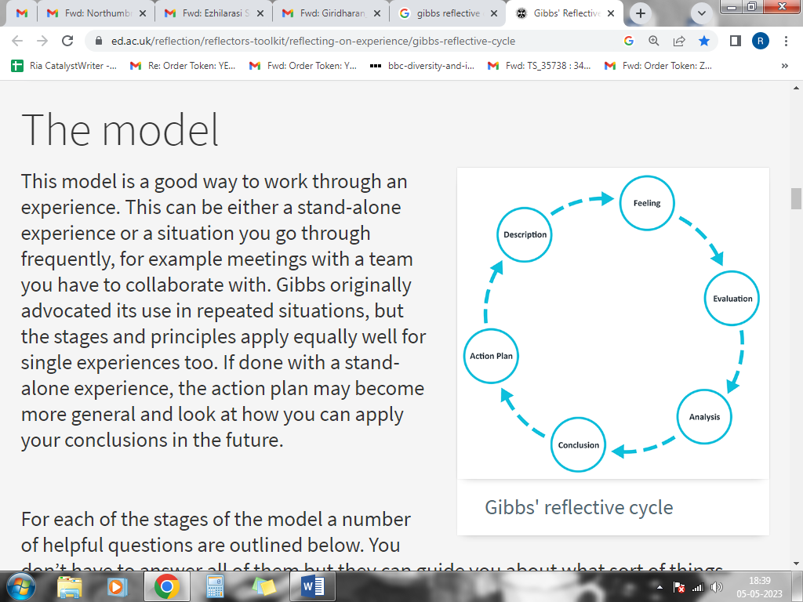
Figure 1: Gibbs Reflective Cycle
(Source: Adeani, Febriani and Syafryadin 2020)
The presented pictorial presentation is the representation of the “Gibbs reflective cycle” that entails the aspects of all of the units and the dimensions that are prevalent in the model and, in turn, presents all of the facets that are likely to be evaluated. It is for this particular reason that I have taken into consideration this model and this particular framework in order to cater to the assimilation of the various learning outcomes that I have experienced and also been a part of in this course and the presentation of this study through the comprehended dissertation within it.
In the first unit of the framework, the segment of Description is pivoted, and this leads to the aspect that there are several reasons for the project being provided to us (Adeani, Febriani and Syafryadin 2020). I have realised that the project was provided to us because of the reason that it called for the assimilation of all of the learning facets that have been entailed along with the derivation of the assessment on the self. Moreover, the research topic and the arena that I have chosen are also reflective of the various factors that I have known and will assist me in the further aspect of my life and career (Roedema et al., 2022). Assessing the healthcare sector that is dominant in the United Kingdom is one of the most withstanding industries and also holds an exponential amount of significance. Moreover, this research has also delved into the facets of technology because of the fact that it takes into account the deliverance of a more systematic and seamless experience in the operational function that is involved within the system.
In the following unit, the factors associated with Feelings have been presented. These ensembles both the positive feeling as well as negative feelings. As I progressed with the course, and was also able to attain several skills through the process of facilitating this project, I was attaining several skills (Roedema et al., 2022). Thus I attained cognitive assessment skills as well as the skills needed for research and note-taking. Moreover, my time management skills were also progressing in this process of enhancing my investigation within the dissertation. The negative feelings and the pessimism reside in the fact that I was sceptical on several instances in regard to the completion of the project on time, as I was given a restricted submission date.
The following segment of Evaluation is susceptive to the fact that this demands the assessment of all of the facets that are learned by me to be evaluated intricately. The analysis of the previous research has showcased me to understand the various ways that technological aspects like Big Data are being utilised in organisations associated with healthcare (Pieper et al., 2021). Moreover, the necessary methods and techniques that have been used in this section are also necessary for the assimilation of understanding the process that is needed for the derivation of the results. Therefore, it is through this process that I learned the aspects of the complete completion of the results. This segment has also showcased that there is a need for the resolution of making the research associative with the data that is being procured in order to cater to deriving the appropriate and the most suitable results. Moreover, this also suggests that fact that I have been able to learn several aspects of the fact that there are ways through which the research is to be conducted in an effective manner (Pieper et al., 2021).
In the next segment of Analysis, I will be reviewing all of the experiences as well as the facets that are needed for the assimilation of self reflection in this dominion. I have attained and identified the fact that all of the learning outcomes that I have learned through this aspect is needed to be attained in a way that is likely to be used in the upcoming prospects (Sekarwinahyu et al., 2019). Thus the presentation of the various facets that are needed for the aspect of representing the overall experiences that I have been a part of in the completion of the study (Sekarwinahyu et al., 2019). Moreover, in terms of skills, as well. I have analysed the fact that there are skills that I have mastered and effectively attained through the experience in the study, along with the fact that I have also gained the realisation of the fact that there are skills that are needed for the purpose of making an effective future prospectus.
The last two segments of the Conclusion and Action Plan are the segments that encompass the various elements that are needed for the purpose of making the research more effective in terms of summarising the various elements that are needed in this domain (Sekarwinahyu et al., 2019). Therefore I would like to state that I have attained significant elements in the research that has enabled me to realise the various elements that are needed for the future as I realised that skills like time management are one of the skills and learning that I would be required to work on in order to proceed with the upcoming projects.

Reference List
Adeani, I.S., Febriani, R.B. and Syafryadin, S., (2020). USING GIBBS’REFLECTIVE CYCLE IN MAKING REFLECTIONS OF LITERARY ANALYSIS. Indonesian EFL Journal, 6(2), pp.139-148. https://journal.uniku.ac.id/index.php/IEFLJ/article/view/3382
Agrawal, R. and Prabakaran, S., (2020). Big data in digital healthcare: lessons learnt and recommendations for general practice. Heredity, 124(4), pp.525-534. https://www.nature.com/articles/s41437-020-0303-2
Chinnaswamy, A., Papa, A., Dezi, L. and Mattiacci, A., (2019). Big data visualisation, geographic information systems and decision making in healthcare management. Management Decision, 57(8), pp.1937-1959. https://www.emerald.com/insight/content/doi/10.1108/MD-07-2018-0835/full/html
Dash, S., Shakyawar, S.K., Sharma, M. and Kaushik, S., (2019). Big data in healthcare: management, analysis and future prospects. Journal of Big Data, 6(1), pp.1-25. https://link.springer.com/article/10.1186/s40537-019-0217-0
Ferraris, A., Mazzoleni, A., Devalle, A. and Couturier, J., (2019). Big data analytics capabilities and knowledge management: impact on firm performance. Management Decision, 57(8), pp.1923-1936. https://www.emerald.com/insight/content/doi/10.1108/MD-07-2018-0825/full/html
Galetsi, P. and Katsaliaki, K., (2020). A review of the literature on big data analytics in healthcare. Journal of the Operational Research Society, 71(10), pp.1511-1529. https://www.tandfonline.com/doi/abs/10.1080/01605682.2019.1630328
Granić, A. and Marangunić, N., (2019). Technology acceptance model in educational context: A systematic literature review. British Journal of Educational Technology, 50(5), pp.2572-2593. https://bera-journals.onlinelibrary.wiley.com/doi/abs/10.1111/bjet.12864
Hawkins, M., Cheng, C., Elsworth, G.R. and Osborne, R.H., (2020). Translation method is validity evidence for construct equivalence: analysis of secondary data routinely collected during translations of the Health Literacy Questionnaire (HLQ). BMC medical research methodology, 20(1), pp.1-13. https://bmcmedresmethodol.biomedcentral.com/articles/10.1186/s12874-020-00962-8
Healthcareers, (2023). Worker training programmes in NHS. [Online] Accessed at: https://www.healthcareers.nhs.uk/career-planning/career-planning/study-and-training/study-and-training [Retrieved on: 3rd of April 2023].
Iovino, F. and Tsitsianis, N., (2020). The methodology of the research. In Changes in European energy markets. Emerald Publishing Limited. https://www.emerald.com/insight/content/doi/10.1108/978-1-83909-107-020201004/full/html
Itrexgroup, (2023). Challenges of big data analytics for the UK healthcare companies. [Online] Accessed at: https://itrexgroup.com/blog/big-data-in-healthcare-examples-problems-benefits/ [Retrieved on: 3rd of April 2023].
Karale, U., (2020). Research Methodology: Introduction to Research; Advantages and Disadvantages of a Questionnaire; Questionnaire Development and Characteristics of a Good Questionnaire; Advantages and Disadvantages of Primary Data and Secondary Data; Difference between Primary and Secondary Data; Primary Data and Secondary Data: Meaning and Explanation. http://125.99.47.158:8090/jspui/handle/123456789/756
Khanra, S., Dhir, A. and Mäntymäki, M., (2020). Big data analytics and enterprises: a bibliometric synthesis of the literature. Enterprise Information Systems, 14(6), pp.737-768. https://www.tandfonline.com/doi/abs/10.1080/17517575.2020.1734241
Khanra, S., Dhir, A., Islam, A.N. and Mäntymäki, M., (2020). Big data analytics in healthcare: a systematic literature review. Enterprise Information Systems, 14(7), pp.878-912. https://www.tandfonline.com/doi/abs/10.1080/17517575.2020.1812005
Kleinheksel, A.J., Rockich-Winston, N., Tawfik, H. and Wyatt, T.R., (2020). Demystifying content analysis. American journal of pharmaceutical education, 84(1). https://www.ajpe.org/content/84/1/7113.abstract
Lindgren, B.M., Lundman, B. and Graneheim, U.H., (2020). Abstraction and interpretation during the qualitative content analysis process. International journal of nursing studies, 108, p.103632. https://www.sciencedirect.com/science/article/pii/S0020748920301164
Mikalef, P., Boura, M., Lekakos, G. and Krogstie, J., (2019). Big data analytics and firm performance: Findings from a mixed-method approach. Journal of Business Research, 98, pp.261-276. https://www.sciencedirect.com/science/article/pii/S014829631930061X
Panch, T., Mattie, H. and Celi, L.A., (2019). The “inconvenient truth” about AI in healthcare. NPJ digital medicine, 2(1), p.77. https://www.nature.com/articles/s41746-019-0155-4
Pastorino, R., De Vito, C., Migliara, G., Glocker, K., Binenbaum, I., Ricciardi, W. and Boccia, S., (2019). Benefits and challenges of Big Data in healthcare: an overview of the European initiatives. European journal of public health, 29(Supplement_3), pp.23-27. https://academic.oup.com/eurpub/article-abstract/29/Supplement_3/23/5628051
Pastorino, R., De Vito, C., Migliara, G., Glocker, K., Binenbaum, I., Ricciardi, W. and Boccia, S., (2019). Benefits and challenges of Big Data in healthcare: an overview of the European initiatives. European journal of public health, 29(Supplement_3), pp.23-27. https://academic.oup.com/eurpub/article-abstract/29/Supplement_3/23/5628051
Patel, M. and Patel, N., (2019). Exploring Research Methodology. International Journal of Research and Review, 6(3), pp.48-55. https://www.academia.edu/download/63543152/IJRR001120200605-115829-bxlrli.pdf
Pieper, M., Roelle, J., vom Hofe, R., Salle, A. and Berthold, K., (2021). Feedback in reflective journals fosters reflection skills of student teachers. Psychology Learning & Teaching, 20(1), pp.107-127. https://journals.sagepub.com/doi/pdf/10.1177/1475725720966190
Pramanik, P.K.D., Pal, S. and Mukhopadhyay, M., (2022). Healthcare big data: A comprehensive overview. Research anthology on big data analytics, architectures, and applications, pp.119-147. https://www.igi-global.com/chapter/healthcare-big-data/290979
Roedema, T., Rerimassie, V., Broerse, J.E.W. and Kupper, J.F.H., (2022). Towards the reflective science communication practitioner. Journal of Science Communication, 21(4), p.A02. https://jcom.sissa.it/archive/21/04/JCOM_2104_2022_A02.abstract
Sánchez, L., Leiva, V., Galea, M. and Saulo, H., (2021). Birnbaum‐Saunders quantile regression and its diagnostics with application to economic data. Applied Stochastic Models in Business and Industry, 37(1), pp.53-73. https://onlinelibrary.wiley.com/doi/abs/10.1002/asmb.2556
Saunders, M., Lewis, P.H.I.L.I.P. and Thornhill, A.D.R.I.A.N., (2007). Research methods. Business Students 4th edition Pearson Education Limited, England. https://www.researchgate.net/profile/Mark-Saunders-10/publication/330760964_Research_Methods_for_Business_Students_Chapter_4_Understanding_research_philosophy_and_approaches_to_theory_development/links/5c53056f299bf12be3f0e2cf/Research-Methods-for-Business-Students-Chapter-4-Understanding-research-philosophy-and-approaches-to-theory-development.pdf
Sekarwinahyu, M., Rustaman, N.Y., Widodo, A. and Riandi, R., (2019), February. Development of problem based learning for online tutorial program in plant development using Gibbs’ reflective cycle and e-portfolio to enhance reflective thinking skills. In Journal of Physics: Conference Series (Vol. 1157, No. 2, p. 022099). IOP Publishing. https://iopscience.iop.org/article/10.1088/1742-6596/1157/2/022099/meta
Selvi, A.F., (2019). Qualitative content analysis. In The Routledge handbook of research methods in applied linguistics (pp. 440-452). Routledge. https://www.taylorfrancis.com/chapters/edit/10.4324/9780367824471-37/qualitative-content-analysis-ali-fuad-selvi
Sheng, J., Amankwah‐Amoah, J., Khan, Z. and Wang, X., (2021). COVID‐19 pandemic in the new era of big data analytics: Methodological innovations and future research directions. British Journal of Management, 32(4), pp.1164-1183. https://onlinelibrary.wiley.com/doi/abs/10.1111/1467-8551.12441
Shilo, S., Rossman, H. and Segal, E., (2020). Axes of a revolution: challenges and promises of big data in healthcare. Nature medicine, 26(1), pp.29-38. https://www.nature.com/articles/s41591-019-0727-5
Shilo, S., Rossman, H. and Segal, E., (2020). Axes of a revolution: challenges and promises of big data in healthcare. Nature medicine, 26(1), pp.29-38. https://www.nature.com/articles/s41591-019-0727-5
Sileyew, K.J., (2019). Research design and methodology (pp. 1-12). Rijeka: IntechOpen. https://books.google.com/books?hl=en&lr=&id=eqf8DwAAQBAJ&oi=fnd&pg=PA27&dq=research+methodology+secondary+data&ots=cKT06UadPe&sig=5XCDJN02b3y2_8UPjDAVefE2PdQ
Sousa, M.J., Pesqueira, A.M., Lemos, C., Sousa, M. and Rocha, Á., (2019). Decision-making based on big data analytics for people management in healthcare organizations. Journal of medical systems, 43, pp.1-10. https://link.springer.com/article/10.1007/s10916-019-1419-x
Statista, (2023). Annual nurses employed at NHS. [Online] Accessed at: https://www.statista.com/statistics/488919/england-nhs-nurse-employed/ [Retrieved on: 3rd of April 2023].
Statista, (2023). Technologies with the biggest impact in healthcare over the last year according to healthcare workers in the U.S. and the UK as of 2021 [Online] Available at: https://www.statista.com/statistics/1265763/impact-of-healthcare-technologies-in-the-us-and-the-uk/ [Accessed on: 3rd April, 2023]
Vogel, C., Zwolinsky, S., Griffiths, C., Hobbs, M., Henderson, E. and Wilkins, E., (2019). A Delphi study to build consensus on the definition and use of big data in obesity research. International Journal of Obesity, 43(12), pp.2573-2586. https://www.nature.com/articles/s41366-018-0313-9
Yang, J., Li, Y., Liu, Q., Li, L., Feng, A., Wang, T., Zheng, S., Xu, A. and Lyu, J., (2020). Brief introduction of medical database and data mining technology in big data era. Journal of Evidence‐Based Medicine, 13(1), pp.57-69. https://onlinelibrary.wiley.com/doi/abs/10.1111/jebm.12373
Yang, J., Li, Y., Liu, Q., Li, L., Feng, A., Wang, T., Zheng, S., Xu, A. and Lyu, J., (2020). Brief introduction of medical database and data mining technology in big data era. Journal of Evidence‐Based Medicine, 13(1), pp.57-69. https://onlinelibrary.wiley.com/doi/abs/10.1111/jebm.12373
Yu, W., Zhao, G., Liu, Q. and Song, Y., (2021). Role of big data analytics capability in developing integrated hospital supply chains and operational flexibility: An organizational information processing theory perspective. Technological Forecasting and Social Change, 163, p.120417. https://www.sciencedirect.com/science/article/pii/S0040162520312439

Appendix 1

Chapter 2: Literature Review

2.1 Overview
The domain of utilising technology in companies and organisations irrespective of the sector the organisation is associated with as it caters to the exponential progress as well as fast-paced growth in the organisation. Healthcare is one of the industries on which the masses of a particular nature are highly dependent. Moreover, according to Khanra et al. (2020), it is also identified that the complete progress of a nation is highly dependent on the domain of the kind of healthcare that is being provided to the masses of the nation. Therefore the usage of technologically advanced as well as developed tools in the organisation is needed for the persistence of taking into account the extensive progress in the system and effective serving of care delivery to the patients in need. Big Data analytics is one of the tools that function in diverse ways that effects the data storage as well as processing within the system in order to speed up the process.
This particular segment of the study will be comprehensive of the critical assessment of the literature that is based on the previous studies. This section will cater to the realm of analysing the importance of Big Data along with the identification followed by a critical as well as in-depth analysis of the research that has been already issued on this domain. The challenges that have been faced by the organisation in the incorporation of these aspects as well as the strategic measures that are taken, will also be stated in this section.

2.2 Prominence of “Big Data Analytics” in “Healthcare.”
In recent times it has been identified that the usage of Big Data has been necessary for the determination of taking into account the enablement of enhancement in the realm of healthcare as well as biomedical facets. In order to attain accuracy as well as appropriation, the aspect of “Big data Analytics” is one of the prime requisites. Big Data is needed for the generation of connectivity within the several domains of a particular healthcare organisation. It is seen in the study of Galetsi and Katsaliaki (2020) that there are facets concerning the early detection of diseases as well as the elevation in the improvement of patient care is one of the aspects that showcases the significance of Big data in the domain of organisations that are associative to healthcare. Moreover, it is also necessary for the purpose of elevating the community services that are needed for the purpose of taking into account the facilitation of the organisation in an effective manner. Moreover, as per the analysis of Yu et al. (2021), there is an exponential bulk amount of clinical data as well as documentation that is generated in a healthcare organisation, and thus, there is a need for sustaining connectivity as well as fast-paced accessibility data, which is efficiently enabled by the analytical tool and technique, associated with Big Data. The aspect of Big Data is one of the most efficient tools that is implemented in the system of an organisation in order to upgrade the system and also make the functionality more effective so that the care delivery of the organisation is uplifted. Moreover, it also includes that there is a need for technological infrastructure to upgrade in order to facilitate enhanced changes within the system.
There is an improved requirement for “big data” within the sector of health care, which is to ensure that there is better engagement of these companies with their patients. The insights are accessible by Mikalef et al. (2019) illustrate that there is the utilisation of smart devices inside these companies for measuring the heartbeat and other essential measures, such as analysing their sleeping period and providing them with better satisfaction. Moreover, this guarantees a higher rate of gratification presented for their consumers, which is a mandatory factor for discovering that there is scope for these companies to gain an improved return on their investments, as there is the attainment of an improved rate of new customers by these businesses that are liable of choosing the service that has been provided to them. Additionally, with the use of big data, these healthcare organisations are able to ensure that there are possibilities of treating harmful diseases such as cancer, which is from a higher amount of information gained by the doctors of these companies for using this method.

2.3 Factors that influence Healthcare Organisations to implement Big Data Analytics
There are several factors that are influential in the healthcare organisation that compel organisations to implement Big Data Analytics in the organisation. It has been realised in the study of Sousa et al. (2019) that there are several aspects that make the functionality of the organisation much easier as well as seamless and also help in the attainment of a competitive advantage in the market. Moreover, there have been several crises in recent times that have initiated the need as well as the immediacy in the system. One of the factors that have created an urgency in the implementation of Big Data analytics is that the advent of the pandemic in the year of 2020 has been the most challenging instances and scenario in the contemporary scenario, and thus the aspect of facilitating the technologically advanced tools as well as the formulation of the utilisation of the modern and advanced tools that are needed to be facilitated so that there is an advancement in the functionality of the organisation. The upgradation, as well as the uplifting aspect of the healthcare organisation, is needed to be accounted for in the concerning organisation because it deals with the aspect of care delivery as well as the facilitation of patient care. Moreover, as per the analysis of Dash et al. (2019), it is realised and identified that there are factors that are separated from patient care as well as effective care delivery in the organisations. It is seen that the sustenance of the clinical documentation in the organisation is also one of the facets that are to be maintained in effect over the manner in the organisation. The documentation of the data of the patients as well as the staff and the employees, along with the aspect of recordkeeping of the resources in the organisation, are some of the factors that have to be implemented in the organisation in order to make the functionality of the organisation more effective in nature. Therefore, the incorporation of modern technological tools and techniques is one of the major aspects that cater to the growth of the organisation. Moreover, as per the analysis of Yang et al. (2020), the post-pandemic scenario has reflected the aspect of initiating the realisation pertaining to the importance of maintaining documentation and thus speeding up the process as well as sustaining the security of the data that is feasible and prevalent at a large amount is one of the factors that has influenced the organisations to implement the structure. Moreover, it helps in the attainment of a competitive advantage in the organisation because of the fact that the processing of the data is made more seamless, along with the sustenance of the technical skills and techniques in the organisation. Moreover, the factors that are associated with the business side of the organisation are some of the effective aspects that are required to be taken into account in order to make the organisation to be chosen by more of the patients who are in need of efficient care. Moreover, the operational workforce in associative organisations is the factor that also compelled the organisations to implement big data analytics in the firms. Moreover, the domain of healthcare is one of the major aspects that cater to making an impactful change in the national health of the masses and also caters to the economic development of the organisation. The realm of making diagnostics, as well as technical decision-making, are some of the aspects that are required to be facilitated in an effective manner, and therefore the inclusion of Big data is one of the major requisites in organisations. Moreover, as per the analysis of Ferraris et al. (2019), in case there are efficient diagnostics in the organisation, the deliverance of patient care is also elevated exponentially amount. Moreover, the factors like the realisation concerning the potential of the data are also significant aspect that is necessary for the implementation of advanced technology. Moreover, according to the research of Mikalef et al. (2019), there are several organisations in the developed nations, and the organisations prevalent in those nations that are incorporating advanced technologies and the aspect that is facilitating better as well as elevated healthcare is being formulated in those nations thus, the aspect of making the organisations that do not suffice the latest technologies degrade in providing cater and thus in order to complete in terms of relevance as well as providing efficient care with the aspect of incorporating the technologies is a prime requisite. Moreover, as per the application that is introduced within the system, it is seen that the aspect of taking into consideration the life-saving outcomes can be facilitated. Moreover, in cases of epidemics as well as pandemics, it is seen that organisations are required to make the process more fast-tracked and also cater to the domain of curing the diseases more efficiently is attained and achieved through this process.

2.4 Issues Faced by Healthcare Organisations in Incorporating Big Data Analytics
There are diverse and numerous kinds of issues that are faced by the facet of incorporating Big data Analytics in the organisations of biomedicine as well as health and medicine. One of the most frequent as well as significant challenges that has been faced by organisations is that there has been a lack of governance of data processing. The lack of efficient as well as precise formatting of the data is one of the aspects that is needed to be taken into account for the purpose of realising the issues that are prevailing in this domain. As per the assessment of Chinnaswamy et al. (2019), it has been predominantly identified that there are the most prominent challenge lies in the fact that there is a major issue that is being located in the stage of capturing the data. The implementation of the analytical system within the organisation is the aspect that is needed to be facilitated within the diverse departments that are prevalent within the system. As per Shilo, Rossman and Segal (2020), it is seen that the challenge, however, lies in the fact that there are instances where the data is to be circulated outside the organisation. The decentralised system is efficiently functional, but the issues pertaining to data security are one of the challenges. Moreover, Pramanik, Pal and Mukhopadhyay (2022), it is also seen that organisations have to invest in the incorporation of technology as well as training the staff and the employees for the efficient functioning of the system. Therefore, the financial strain faced by small-scale healthcare facilities is one of the major issues that are being confronted by organisations.
Healthcare bodies are considered to face challenges while utilising big data in their business processes due to the workers in these companies lacking adequate knowledge pertaining to formulating these processes. The insights gained from the study of Price and Cohen (2019) illustrate that there is a higher requirement of knowledge by the workforce of these companies to discover that these businesses have skilled workers in order to utilise the big data, as this technology requires better knowledge of their employees for executing their organisational operations relating to this feature. However, due to a lack of knowledge in the workforce of the healthcare companies, there are challenges experienced by these enterprises, which results in discovering ineffective implementation of their business methods, resulting in addressing that there is lesser capital gained by these corporations, depicting that there are challenges for these companies to formulate their business processes. Moreover, depicting that their customers are attaining lesser satisfaction from these companies, which poses an adverse impact on their revenue generation process. Nevertheless, due to the work process of these companies being complex, there are possibilities for the workers from these enterprises to misplace or lose essential data, resulting in the creation of challenges for these businesses.

2.5 Technology Organisation Environment Framework
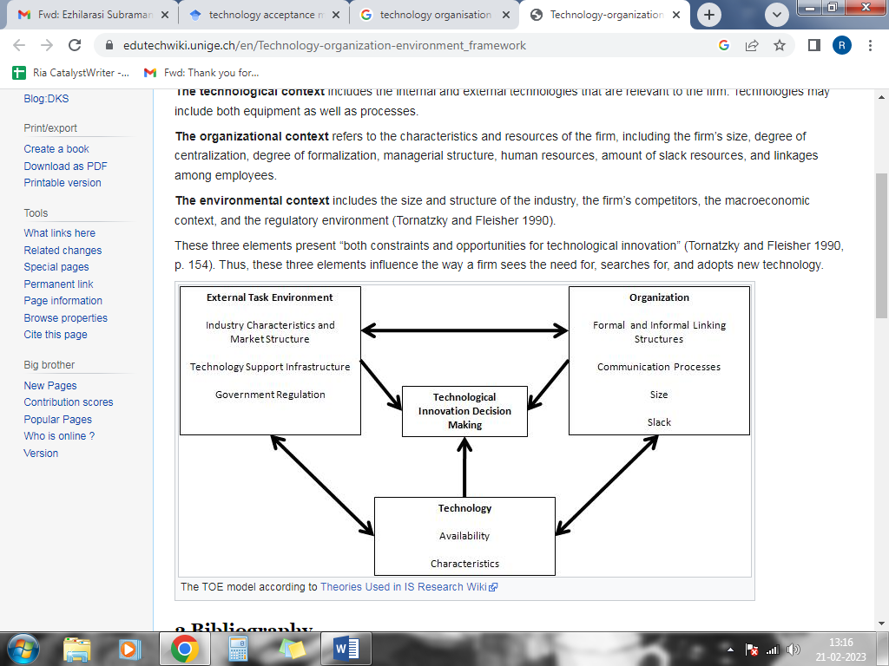
Figure 1: Technology Organisation Environment Framework
(Source: Granić and Marangunić 2019)
The above-presented figure is the presentation of the framework that has been developed by the Technology organisation and environment framework. The model showcases several units and dimensions that are prevalent to realise the conceptualisation of the needs of the technological tool and its benefits as well as the advantages of implementing the nation. The two major dimensions of external tasks as well as the organisational need for use, are the essential aspects that signify the need to take into account the facilitation of the advanced tool and the benefits that can be derived through its use. As per the study of Sheng et al. (2021), the utilisation of Big Data is needed for the purpose of decentralising the data in the organisation and increasing the accessibility organisation. The ease in the usage of the tool lies in the fact that it leads to increased efficiency as well as the performance level of the organisation. It is also realised that the characteristic of taking into account the facilitation of the connectivity of the data within the diverse domains of the organisations of healthcare is the ease that has made the usage of this theoretical framework necessary.

2.6 Strategies for Incorporating Big Data Analytics in Healthcare Organisations
There are diverse strategic measures that are taken for the formulation of an effective strategy that is needed for the purpose of implementing the usage of Big data and deriving the major advantageous aspects from its use. As per the analysis of Khanra, Dhir and Mäntymäki (2020), there are benefits to the use of high-quality training data that can be sufficed through its usage. The facet concerning inurement of the trust of the providers is attained through big Data in the health and medicine associative organisations. Moreover, the facilitation of the analytical support data is also one of the facets that are needed to be sufficed through the tool. One of the major aspects that cater to the inclusion of this tool and technique within the system is that there is a probability of attaining human errors, and thus the maintenance of efficiency in the domain of record generation as well as bookkeeping is attained. There are possible factors that are likely to cause challenges in this domain, and it has been seen that the aspect of taking under consideration the elimination of errors in the inclusion of the technology is formulated. However, there is significant growth in the domain of healthcare organisation and care delivery, and thus the training of the employees pertaining to the usage of the tools is being initiated. According to (), the utilisation of high-quality training data is one of the major factors that is required to be taken into consideration in the case of Big Data inclusion. Moreover, the incorporation of bias-less AI (Artificial Intelligence) is also one of the approaches that have been initiated and assist healthcare organisations in attaining more efficacy within the system.

2.7 Literature Gap
In this study, there has been an all-encompassing inclusion of the various and diverse aspects that have been studied through the existing research. The studies that are included in the domain of Big Data Analytical systems as well as also facilitate the inclusion of the technology in the domain of healthcare and the organisations that are intermittent within this aspect. The need for the adoption of big data analytics in organisations has been stated along with the factors that influence the healthcare organisation to adopt the strategies along with the issues that are faced while there is the adoption as well as implementation along with the struggles that are initiated in order to cater to the domain of making the organisation mitigate the challenges. However, there is a lack of data concerning the training of the employees as well as the hiring and recruitment of the employees based on their adaptability to the technical skills that makes an impact on the organisation. Moreover, the training processes, as well as the workshops that are facilitated, are in need of cost as well as investment and thus, the data concerning this area has been lacking and, therefore, will be addressed in the segment of data analysis.

2.8 Conceptual Framework

Big Data Analytics in Healthcare
Significance
Factors
Issues
Strategies
Efficiency in the organization, data security
Cut down costs and efficient diagnosis
Lack of training and awareness, greater investments
Training and unbiased AI tools

Figure 3: Conceptual Framework
(Source: Created by author)

The above-presented figure is the representation of the significant elements that are prevalent in the system. It is realised that the compartmentalisation of all the units that have been mentioned in this domain are needed to be facilitated so that it derives the outcome of the research. The representation of the arrows that are prevalent in the system is necessary as it shows the sequence that is sustained in the figure.

2.9 Summary
There are several aspects that have been highlighted in this chapter of the dissertation. The studies that already exist and have been issued in this aspect have been taken, and the critical analysis based on this facet has been analysed. Therefore it is also understood that the aspect of taking into explanation the analysis of all the aspects that have been covered concerning the arena of Big data as well as the healthcare organisations have been addressed. Moreover, the gap or the breach in the data has been realised along with the presentation of the theoretical framework and the domain of making the realisation of the most significant aspects. The presentation of the framework also showcases that there are significant highlighting factors that are needed to be facilitated in order to realise the major outcomes of the study.

Chapter 3: Research Methodology

3.1 Overview
This episode will facilitate the procedures that are selected in the study in order to categorise the significance of the methods that will cater to the execution of the study. The research is oriented toward the aspect of analysing the need as well as the analysis of the impact of Big Data in the healthcare sector and the organisations within it, and thus, the aspect of assessing the qualitative data will be considered. The presentation of the Onion will be shown, and it will be required to realise the categorisation of each of the processes as well as the techniques that are prevalent and the necessity of each of the tools based on the data that will be required.

3.2 Research Onion
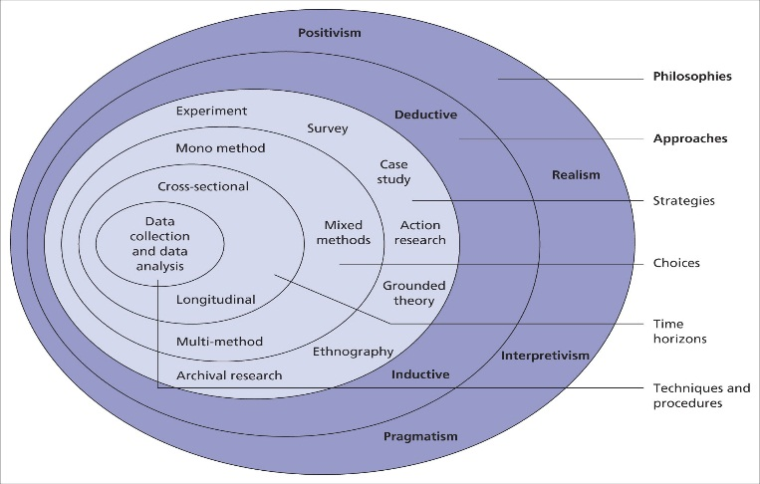
Figure 3: Research Onion
(Source: Saunders et al., 2007)
The depicted figure is the arrangement of the Research onion, which is considered to be one of the most efficient tools for the researcher needed to formulate a particular investigation. Based on the kind as well as the category of the data that has been selected, it is seen that the techniques for each method are being chosen (Saunders et al., 2007). Moreover, as the qualitative data will be taken, therefore the methodologies that will be selected are based on the aspect of making the choices as per the tools that will suffice the completion of the execution of the research.

3.3 Research Paradigm
The model or the philosophy of the study that will be effectively chosen in this study is the Interpretivism philosophy. This philosophy has been opted by the investigator because of the fact that the research deals with the domain of healthcare, and this paradigm is needed to delve into the facets that are associated with the social as well as the phenomenological aspects (Sánchez et al., 2021). Therefore the analysis of the perception of the researcher will be based on the aspect of making the interpretation of this domain. Moreover, this method will also cater to the evaluation of the contextual aspects of the data set that is procured, and the formulation of the research will be based on the facets concerning the interpretive philosophy.

3.4 Research Approach
The method that is taken into consideration in this study is the “Inductive methodology”. This precise method is selected because of the fact that the study concerning the theories as well as the concepts is executed and better accomplished through this approach. Moreover, there is a need to make the study flexible, which will eventually cater to the possibility of developing newer theories through the process of the research (Sileyew, 2019). It has been realised that the research is comprehensive in understanding the frameworks pertaining to technology and the ways in which it is being adopted by the healthcare organisation; therefore, this approach has been chosen as per the suitability of the study.

3.5 Research Strategy
The “Case study” method has been elected in the study because of the fact that the emphasis has been laid on the healthcare organisation specifically. This strategy helps the researcher to be authentic as well as articulate in the research, and the procurement of the information is based on the exclusivity of the scenario or the domain that has been chosen (Karale, 2020). Moreover, it is through this strategic approach that the complex aspects that are theoretically prevalent can be translated into the realm plane. Therefore the theoretical aspects of technological development in the organisation are studied, as well as the real-life implication of the methods in the hospitals and the organisations associated with healthcare practised.

3.6 Time horizon
The time Horizon that is present as an option to the researcher is the “Longitudinal time horizon” as well as the “cross-sectional” time horizon. However, in order to execute the study, the aspect of the Longitudinal time horizon was. The sources that have been selected for the accumulation of the data are catered to being conducted for an extended period of time, and therefore the facilitation of this time horizon is considered (Hawkins et al., 2020). The other is not considered because the study is not facilitated at a particular or a given point in time.

3.7 Research Design
The research design that is considered by the researcher in order to suffice the suitability of the research, as well as the investigation, is the descriptive design. The formulation of the research caters to the deconstruction of the context in the social front as well as the study concerning a population that is the healthcare organisation, and therefore this design will assist the research in attaining significant results at its completion (Patel and Patel, 2019). Therefore in order to justify the methods that are facilitated in the research and the basis of the analysis of the qualitative data is one of the factors that is considered in order to execute the study.

3.8 Research Choice
There are two significant choices that are prevalent to the researcher. The study can either be conducted through the utilisation of the mono method or the application of the mixed method. In this study, the mono method will be used as this research caters to the selection of one kind of data, that is, the qualitative data along with the data that is empirical and the statistical data that is a part of the procured data set (Iovino and Tsitsianis, 2020). Therefore the use of the mono method has been opted for. Moreover, it will cater to the facilitation of the research built on the data set that has already been documented, and the formulation of the data based on the secondary methods will be considered.

3.9 Keywords
The selection of the keywords is one of the prime requisites in the study as it tends to generate the search operation needed to execute the study. The sources that are to be selected will be facilitated on the basis of making the investigation move in a suitable direction. The selected keywords followed by the selection are formulated through the Boolean operator, and the search operation is generated (Lindgren, Lundman and Graneheim, 2020). In this study, the sources are being procured through the keywords such as “Big Data”, “Healthcare”, “Technology”, etc.

3.10 Inclusion/Exclusion
The “inclusion and exclusion criteria” are needed to facilitate the filtration of the articles and journals that are likely to be used in the study. The inclusion criteria state the aspects that are required to be considered for the selection of the sources that are intended to procure the data set. The sources that are issued in the English language and also published in the year 2018 will be included (Kleinheksel et al., 2020). Furthermore, the selection of open-access sources will be considered, and the research sources that are related to this research topic of Big Data analytics in healthcare will be chosen, respectively.
The sites containing information and data prior to 2018 will be disregarded as they would not provide implications of results that are updated and aligned with the concurrent business scenario. The sources that are published in other languages excluding English, and do not show relevant data on the research topic will also be excluded from the overall investigation.

3.11 Data Collection
There are different types and categories in which relevant and authentic data and information are collected for particular research. The main categories in which the data collection processes are divided include “primary data collection” and “secondary data collection” with respect to the research onion (Selvi, 2019). As the nature of this investigation favour collection and evaluation of secondary data, presented in qualitative and empirical form, therefore, this process is suitable for the analysis of healthcare organisation, and the difference is statistics pertaining to the advancement of the technological infrastructure in the organisation is stated.

3.12 Data Analysis
The examination of the data that is prevalent to the researcher is based on the viable options that are needed to be taken into account. Therefore as the research is grounded on the qualitative analysis of the data set that has been procured, it is seen that the Content analysis tool has been chosen as the most viable method (Kleinheksel et al., 2020). The aspect of analysing the interpretation of the researcher based on the data that is assimilated and the evaluation of the ancillary aspects that are seen is facilitated.

3.13 Ethical Consideration
There are several ethical procedures that are to be accepted in order to execute the reading. It is seen that the “GDPR” (“General Data Protection Reregulation”) guidelines will be trailed along with the guidelines that are formulated by the University (Hawkins et al., 2020). Moreover, the data that is collected will be saved in a USB device and will be kept under the protection of a password so that there is no external tampering of the data that are likely to cause hindrances in the results. Moreover, only credible as well as authentic as well as authentic data will be selected.

3.14 Summary
This chapter projects the feasible methods that are required to be analysed in the research, and it can be realised that the processes that have been selected will cater to the authenticity of the results in the evaluation followed by the collection of the data.

Chapter 4: Data Analysis and Findings

4.1 Overview
The UK healthcare companies are locating better convenience in the completion of their firm processes, with the use of “big data analytics”, which caters for the workers with better satisfaction from employing their firm practices in obtaining a higher return on investments. Moreover, within this section, there will be an illustration of the significance of using “big data” for UK health-oriented firms, along with illustrating the factors that influence these corporations to use these methods. Furthermore, the issues that are confronted by the UK fashion companies will be illustrated in this section, along with illustrating the strategies used by these firms in gaining the utilisation of their business processes related to “big data analytics”.
This particular part of this research will illustrate the sources for the presented topic through the use of statistical graphs and numeric data that is required for evaluating the role of “big data” in UK nursing homes. Moreover, the sources that are obtained from the part of “literature review” and the “secondary data analysis” will be depicted and discussed in this section.

4.2 Secondary Data Analysis
4.2.1 Eminence of Big Data Analytics in the Healthcare Sector of the UK
The healthcare sector that is prevalent in the domain of the “United Kingdom” is one of the most effective innovations that has catered to the alterations that are needed to be attained for the uplifting aspects of the organization. The National Healthcare Service prevailing in the UK is likely to utilize several technological tools, and the recent technical infrastructure of the organization has been upgraded with the diverse usage of the technologies in the organizations. The use of Big Data has been facilitative in these organizations as it helps and assists the organizations in the generation of the managing the clinical documentation as well as the enlarged database that is needed for the organization. The usage of “Big Data analytics” has been helping organizations that are associative with NHS in the domain of making the sector attain a competitive advantage in the organization (Statista, (2023). It is also realized that the organizations’ need for data security has been maximized with the usage of the tools. With the implementation of technology in the management of the database in the organization the requirement of assessing security is one of the prime needs in the organizations.
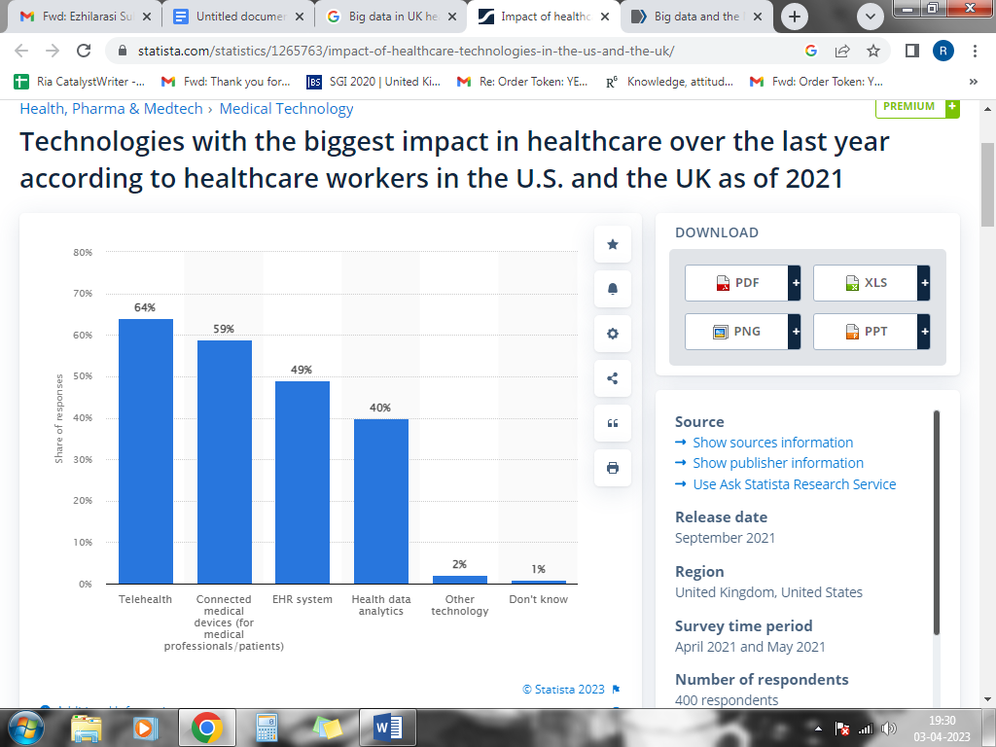
Figure 4: Technologies affecting healthcare
(Source: Statista, (2023).
The representation of the above given statistical evidence of the data is needed to realize the increasing need for formulating the technological tools and the methods in the realm of managing the data of the organizations (Statista, (2023). One of the most used technological tools is telehealth services. This is also one of the most prominent innovations that are needed for the purpose of making the organization facilitate in an effective manner. Healthcare data analytics, as per the evident data, showcases the fact that the requirement and the facilitation of big data have been 40 per cent in the NHS.
4.2.2 Factors Influencing the Utilisation of big data analysis for the UK healthcare companies
The presence of various factors has been responsible for the UK construction companies to use “big data analysis” inside their organisations. Moreover, with the use of “Big data”, the NHS are capable of finding out enhanced elimination of their organisational operations, which caters for these companies with the scope of gaining information relating to the sickness of their patients, in which there are better holdings of the records that are inside these businesses which cater the scope for these enterprises to obtain improved revenue generation, which is an influence that instructs these corporations in utilising these methods. Furthermore, the utilisation of these types of machinery by healthcare firms addresses the effective attainment of new workers by these firms, which is a factor that influences the use of these technologies by these companies (Statista, 2023).
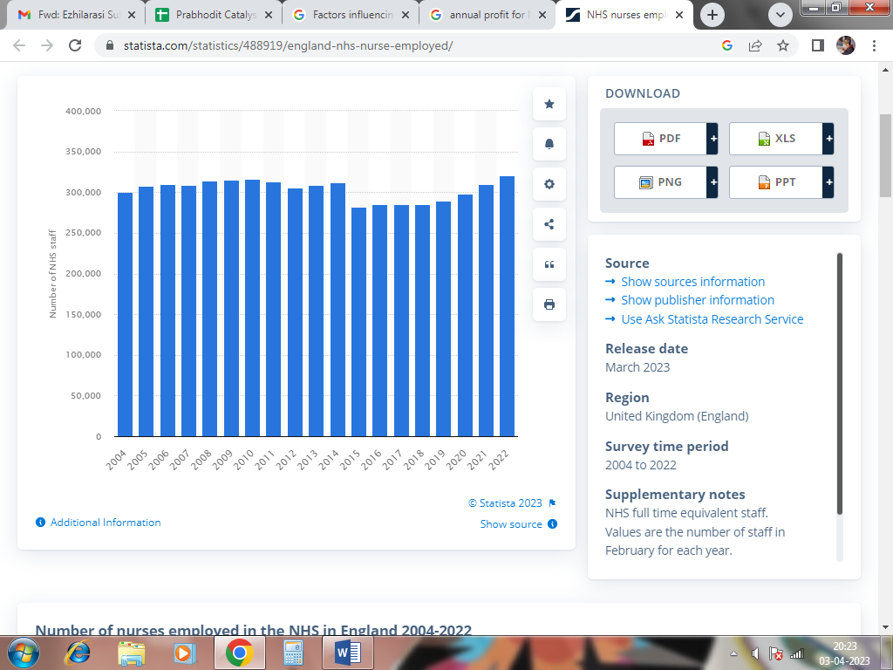
Figure 5: Annual Nurses Employed at NHS
(Source: Statista, 2023)
The depiction represented appraises that there is a higher attraction of nurses that are willing to operate in the companies that use big data analytics in their organisation. Moreover, it is depicted that, in 2019, this company recruited 289,759 nurses in their recruiting process, which is from the use of this technology in their company. Additionally, in 2020, there were 298,632 nurses in this firm, which depicts that there is better convenience catered to the workforce of this company from the use of these technologies. Furthermore, in 2021, this company obtained 309,631 total healthcare workers, which in 2022 enhanced to 321,018 from the use of big data in their business methods (Statista, 2023).
4.2.3 Challenges faced by the UK health-oriented companies while using big data
There are numerous welfares gained by the UK healthcare companies from using big data inside their firm processes. However, small and newly established companies are facing challenges while using big data analysis, which is the cost of using these methods is high. Moreover, hindering these corporations from operating with better effectiveness from proper implication, which is a facet that poses an alternative influence on their firm practices. Furthermore, as there is the utilisation of a higher amount of capital in ensuring the attainment of these technologies, there is a presence of challenges, as these businesses lack in terms of capital for instigating completion of their operational tasks that need a higher rate of capital to operate (Itrexgroup, 2023).
There is a need for higher interaction and combination among the employees of the UK healthcare companies for using big data analytics in these companies. However, as there is ineffective interaction among the consumers of these firms, there is an availability of hindrances in these firms. Moreover, this finds out that there is ineffective communication among the workers of these companies, which is labelled to be an aspect that lays an adverse influence on their organisational methods, which finds out that the relevant data regarding the patients of these companies are lost in the process, determining the ineffective treatment of the clients by the UK healthcare enterprises, which poses an adverse impact on their brand image hampering their establishment (Itrexgroup, 2023).
4.2.4 Strategies Used by UK healthcare enterprises while implementing the Use of big data
The UK companies that are oriented towards healthcare are gaining various benefits while using big data inside their firm processes. Moreover, NHS, which is a health-oriented company in the UK, is formulating knowledge campaigns inside their business processes, which ensures the attainment of a workforce that comprises higher knowledge and skills, determining the completion of their projects with better effectiveness. Moreover, there are possibilities for these firms to find out that there is improved utilisation of their business processes, which caters for their patients and their workers with a higher level of satisfaction. Furthermore, this guarantees a hike in the level of gratification for the employees of these companies, which identifies that there is the attainment of enhanced revenue generation by the UK healthcare enterprises, along with deeming that there is the attainment of a higher level of interaction by the workforce of these hospitals, guaranteeing completion of their projects with better effectiveness (Health careers, 2023). Nevertheless, the use of training campaigns pertaining to the use of “big data analytics” is a beneficial factor, which caters the UK fashion corporations with the possibility of obtaining a healthy workplace for their employees from an improved level of communication and interaction among the workers of these firms (Healthcareers, 2023).

4.3 Findings
4.3.1 Importance of “Big Data Analytics” in the Healthcare Sector of the UK
From the critical assessment of the previous researchers, it is realized that there are various factors that reflect upon the prominence of “Big data analytics” in healthcare organizations. It is seen that the increase in the efficiency of the managerial section of the organizations is one of the prominent aspects that are present and inculcated through the research. Moreover, the factors like the increase in data security are also one of the major facets that are being attained through it. The need for the attainment of security is one of the major factors that is reflected in this aspect (Galetsi and Katsaliaki (2020). Through the investigation of the subordinate data that was procured from secondary sources, it is realized that the NHS and the organizations comprehended are in need of data analytics at a 40 per cent rate. Moreover, there are several other technologies that are being implemented in the system so that there are innovations that are encountered in the organizations (Statista, 2023).
4.3.2 Factors that influence the UK healthcare companies to use big data in their firm methods
The sources of data procured from the “literature review” that is prevailing within this “research paper” illustrates that the acquirement of competitive advantage by the healthcare companies is a factor that instructs the use of these techniques in their “firm processes”, which is required element that ensures the generation of better scope in enhancing profit obtainment (Sousa et al., 2019). The part of “secondary data analysis” illustrates that there are various benefits obtained by the UK health-oriented companies, which is subjected to be an aspect that instructs these firms to employ the utilisation of new advancements in their firm processes. Moreover, it is seen that there was the attainment of higher satisfaction by the workers of these enterprises, which is a factor that is essential in ensuring compartment of their projects with higher efficacy, determining that there is better revenue obtained by the UK healthcare companies from the use of these technologies in their “business processes” (Statista, 2023).
4.3.3 Challenges faced by the UK healthcare sector pertaining to the use of big data
The “literary sources” from this study evaluate that the healthcare enterprises are compiled to experience issues during incorporating “big data analytics” due to the workers of these corporations having lesser knowledge in using their business methods, depicting adverse implementation and utilisation of their “organisational operations”, finding out possibilities for this firm in acquiring more of befitting aspects that lay impact on their profitability. Moreover, there are higher skills the employees require to gain better effectiveness in their firm strategies through the integration of “big data”. However, due to a lack of knowledge among the employees, there is a presence of challenges for these businesses (Price and Cohen 2019). According to the data obtained from the section of “secondary data analysis” it is evaluated that, the UK healthcare companies are facing challenges while using their business processes in relation to “big data analytics”, which is from the price of these technologies being high, there is ineffective attainment of profit from the use of these methods which is considered to be a challenge for these businesses (Itrexgroup, 2023).
4.3.4 methods used by the UK health-oriented companies in ensuring utilisation of big data
The data attained from the “literature review” section illustrates the strategies that are used by these firms in completing their methods in their businesses are plenty, pertaining to the use of their big data analysis, for which there was the employment of the training practices to their staff members (Khanra, Dhir and Mäntymäki 2020). The pieces of insights that are available inside “secondary data analysis” illustrates that due to skill among the workers of NHS, which is a healthcare company in the UK, there is a challenge faced by this company in using big data analytics in their firm process. Moreover, “worker training programs” are employed in this business, which finds out that there is effective implementation of their firm practice, which addresses accomplishment of a higher level of effectiveness in their firm methods (Healthcareers, 2023).

4.4 Summary
This segment is formulated to depict the use of “big data analytics” in UK healthcare enterprises and the role of these technologies. Moreover, it is comprehended from this section that there is an enhanced rate of gratification for their consumers, which finds out that there is a positive impact posed on the establishment of the UK health care companies in the international companies. Nevertheless, due to ineffective communication among the consumers of these firms, their attainment of burdens by these businesses. It is concluded from the findings section that the use of “big data” for the NHS is crucial as there is the acquirement of new technologies by the employees of these companies, which aligns with their convenience.

